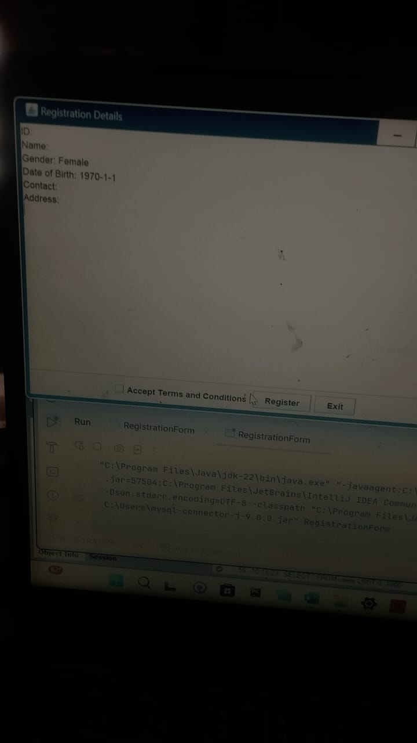  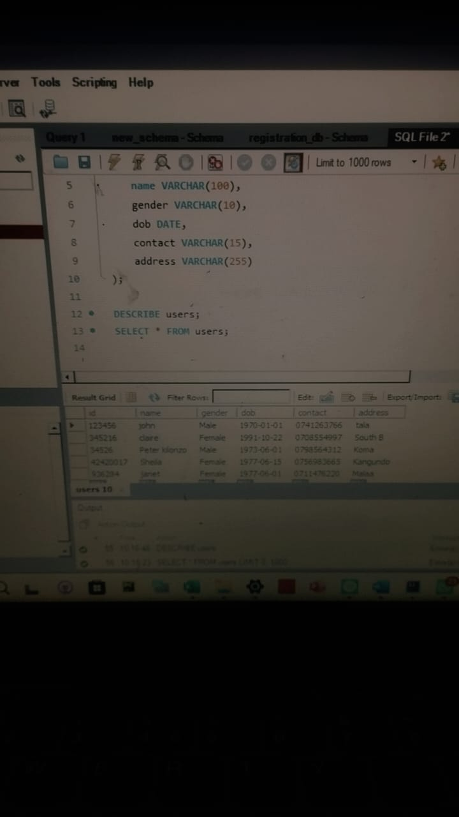

The following code I used to create the database called registration_db:

USE registration_db

CREATE TABLE users (

id VARCHAR(50) PRIMARY KEY,

name VARCHAR(100),

gender VARCHAR(10),

dob DATE,

contact VARCHAR(15),

address VARCHAR(255)

);